

|  |  |  |  |  |  |  |  |  |
| --- | --- | --- | --- | --- | --- | --- | --- | --- |
|  | | | | | | | | |
|  | | Capstone Project – Retail Analytics | | | | |  | |
|  |  | | | | | | |  |
|  | | | |  |  | | | |
|  | | | | Harshad Daulat Sawkar |  | | | |
|  | | | | —Data Analytics—Harshad Daulat Sawkar |  | | | |
|  | | |  | | |  | | |

|  |  |  |  |  |  |  |  |  |
| --- | --- | --- | --- | --- | --- | --- | --- | --- |
|  |  | | |  |  | | |  |
|  | Overview | | | | | | |  |
|  |  | | |  |  | | |  |
|  |  | |  | | |  | |  |
|  |  |  | "Effective retail analytics is needed to tackle challenges in optimizing product assortment, pricing strategies, inventory management, and customer engagement. There is a growing demand for data-driven insights to enhance decision-making in an increasingly competitive retail landscape, where understanding consumer behavior and market trends is crucial for sustainable growth and profitability." | | |  |  |  |
|  | | | | |
|  |  |  |  |
|  |  |

|  |  |  |  |  |  |  |
| --- | --- | --- | --- | --- | --- | --- |
|  | |  |  |  |  | |
|  | | THE PROCESS | | |  | |
|  | |  |  |  |  | |
|  | **1. Data Acquisition from GitHub:**  Obtain the requisite dataset from a designated GitHub repository, containing essential information on university rankings, encompassing various countries and their performance across distinct ranking systems.  **2. Data Transformation and Enhancement:**  If necessary, execute data transformation procedures to ensure data quality and consistency. Additionally, consider augmenting the dataset with new problem statements to enrich the analysis potential.  **3. Connecting with Tools:**  Establish connections between the dataset and various analytical tools. Interface the dataset with Power BI, Excel, and MySQL Workbench, facilitating seamless data integration and processing.  **4. Problem Statement Solution in Power BI:**  Utilize Power BI to delve into the specified problem statements. Employ its robust features for data visualization, exploration, and analysis, effectively deriving insights and solutions.  **5. Exploratory Data Analysis (EDA):**  Perform exploratory data analysis using either Excel or SQL Workbench, depending on the complexity of the analysis. Extract meaningful patterns, relationships, and trends from the data to inform subsequent decision-making.  **6.** **Creation of Visual and Insightful PowerPoint**:  Develop a comprehensive PowerPoint presentation that encapsulates the project's objectives, methodologies, problem statement solutions, and key visualizations. Each problem statement should be accompanied by a dedicated section with pertinent conclusions and insights.  **7. Detailed Documentation:**  Compile a detailed report that meticulously documents the entire project lifecycle. Include sections on data collection, transformation, problem statement formulation, tools integration, Power BI solutions, EDA insights, and PowerPoint visualizations. | | | | |  |

**Objective**

The objective of this project is to develop a Power BI dashboard using the Retail Database to provide comprehensive insights into the retail business's performance. The dashboard will focus on sales, product, customer, and demographic analysis, aiming to facilitate data-driven decision-making, optimize sales strategies, and enhance customer experiences. The goal is to empower retail stakeholders with actionable insights, enabling them to identify top-selling products, customer preferences, and target demographics. The dashboard will offer valuable insights and recommendations for targeted marketing, inventory optimization, and personalized customer experiences. The final deliverables will include a report and presentation showcasing the dashboard's findings and significance, serving as a powerful tool for retail stakeholders to improve business strategies and achieve success in the competitive retail market.

The objective of this project is to develop a Power BI dashboard using the Retail Database to provide comprehensive insights into the retail business's performance. The dashboard will focus on sales, product, customer, and demographic analysis, aiming to facilitate data-driven decision-making, optimize sales strategies, and enhance customer experiences. The goal is to empower retail stakeholders with actionable insights, enabling them to identify top-selling products, customer preferences, and target demographics. The dashboard will offer valuable insights and recommendations for targeted marketing, inventory optimization, and personalized customer experiences. The final deliverables will include a report and presentation showcasing the dashboard's findings and significance, serving as a powerful tool for retail stakeholders to improve business strategies and achieve success in the competitive retail market.

The project will involve the following tasks:

Performing a comprehensive analysis of Retail Analytics, including variations across systems, key factors influencing Profit, profit margin , historical trends, and the impact of limitations on growth

Deriving meaningful conclusions and recommendations for improving Perfrormance methodologies.

Compiling analysis results, conclusions, and recommendations for stakeholders.

The success of the project will be measured by the following metrics:

The quality of the analysis

The relevance of the insights

The impact of the recommendations

This project is significant because it has the potential to improve the quality and competitiveness of higher education institutions worldwide. By understanding the factors that influence university rankings, institutions can better position themselves to succeed in the global marketplace.

**Significance**

The Retail Analytics Capstone Project holds substantial significance in the realm of modern business and data-driven decision-making. As the retail industry continues to evolve, the availability of vast amounts of data has presented both opportunities and challenges. This capstone project aims to address these challenges by leveraging advanced data analytics techniques to extract valuable insights from retail data.

The project's significance lies in its potential to revolutionize the way retailers operate. By analyzing historical sales data, customer behavior, inventory levels, and market trends, the project aims to provide actionable insights that can enhance inventory management, optimize pricing strategies, and personalize the customer experience. This not only has the potential to increase profitability for retail businesses but also improve overall customer satisfaction.

Furthermore, the project's outcomes can contribute to the advancement of retail analytics as a field. The methodologies developed and insights gained can serve as valuable contributions to the broader data science community, aiding researchers in refining their understanding of retail dynamics and predictive modeling.

In a broader context, the project aligns with the current trend of data-driven decision-making across industries. As businesses increasingly rely on data to guide their strategies, the successful implementation of this capstone project can serve as a model for other sectors seeking to harness the power of analytics to enhance their operations.

The Retail Analytics Capstone Project's significance lies in its potential to drive innovation within the retail industry, contribute to the academic and professional understanding of retail analytics, and set an example for data-driven decision-making in contemporary business environments

**Data Dictionary:**

**Table Explanations**

**Offices Table**

This table stores information about the different offices of the retail company,

including the office code: Unique identifier for each Office, city, phone number, address, state, country, postal code, and territory.

Each office is uniquely identified by its office code.

**Employees Table**

The employees table holds data about the company's employees. It includes fields such as

- employee number: a unique identifier for each employee,

last name, first name, extension, email address,

office code: identifying the office where the employee works)

reports to: the employee number of the person to whom the employee reports,

job title.

Customers Table

This table contains information about the retail company's customers. It includes fields like

customer number: a unique identifier for each customer,

customer name, contact last name, contact first name, phone number, address, city, state

postal code, country,

sales representative employee number: identifying the employee responsible for the customer and credit limit.

Products Table

The products table stores details about the various products sold by the retail company. It includes information such as the

product code: a unique identifier for each product, product name,

product line: categorization of the product, product scale, product vendor, product description, quantity in stock, buy price, and Manufacturer's Suggested Retail Price (MSRP).

Product Lines Table

This table is used to describe the different product lines available in the company's inventory. It includes fields such as the

product line name, text description,

HTML description: for web-based content,

image: stored as a BLOB to represent the product line visually.

Orders Table

The orders table stores data related to customer orders. It includes information like the

order number: a unique identifier for each order, order date, required date, shipped date,

order status: using an ENUM for predefined statuses, comments,

customer number: identifying the customer who placed the order as Foreign Key.

Order Details Table

This table contains information about the individual items (line items) included in each order. It includes fields such as the

order number: linking to the orders table Primary Key,

product code: linking to the products table here as Foreign Key,

quantity ordered, price per item, and order line number.

Payments Table

The payments table stores details about payments made by customers. It includes fields such as

customer number: linking to the customers table Foreign Key,

check number, payment date,

payment amount.

Profit Summary Table Act as Helper Table

This table act as a helper table, has details about

* average sell price, Buy Price, Buy Price Per QTY,
* Product Code: linking to Product Table Foreign key, Profit , Profit Margin, Sell Price , Sum of Order Quantity

The data dictionary provides a comprehensive overview of the tables and their respective fields in the dataset. It outlines the relationships between the tables, allowing for a better understanding of the data structure and facilitating the design and implementation of the Power BI Dashboard.

**ER Diagram**

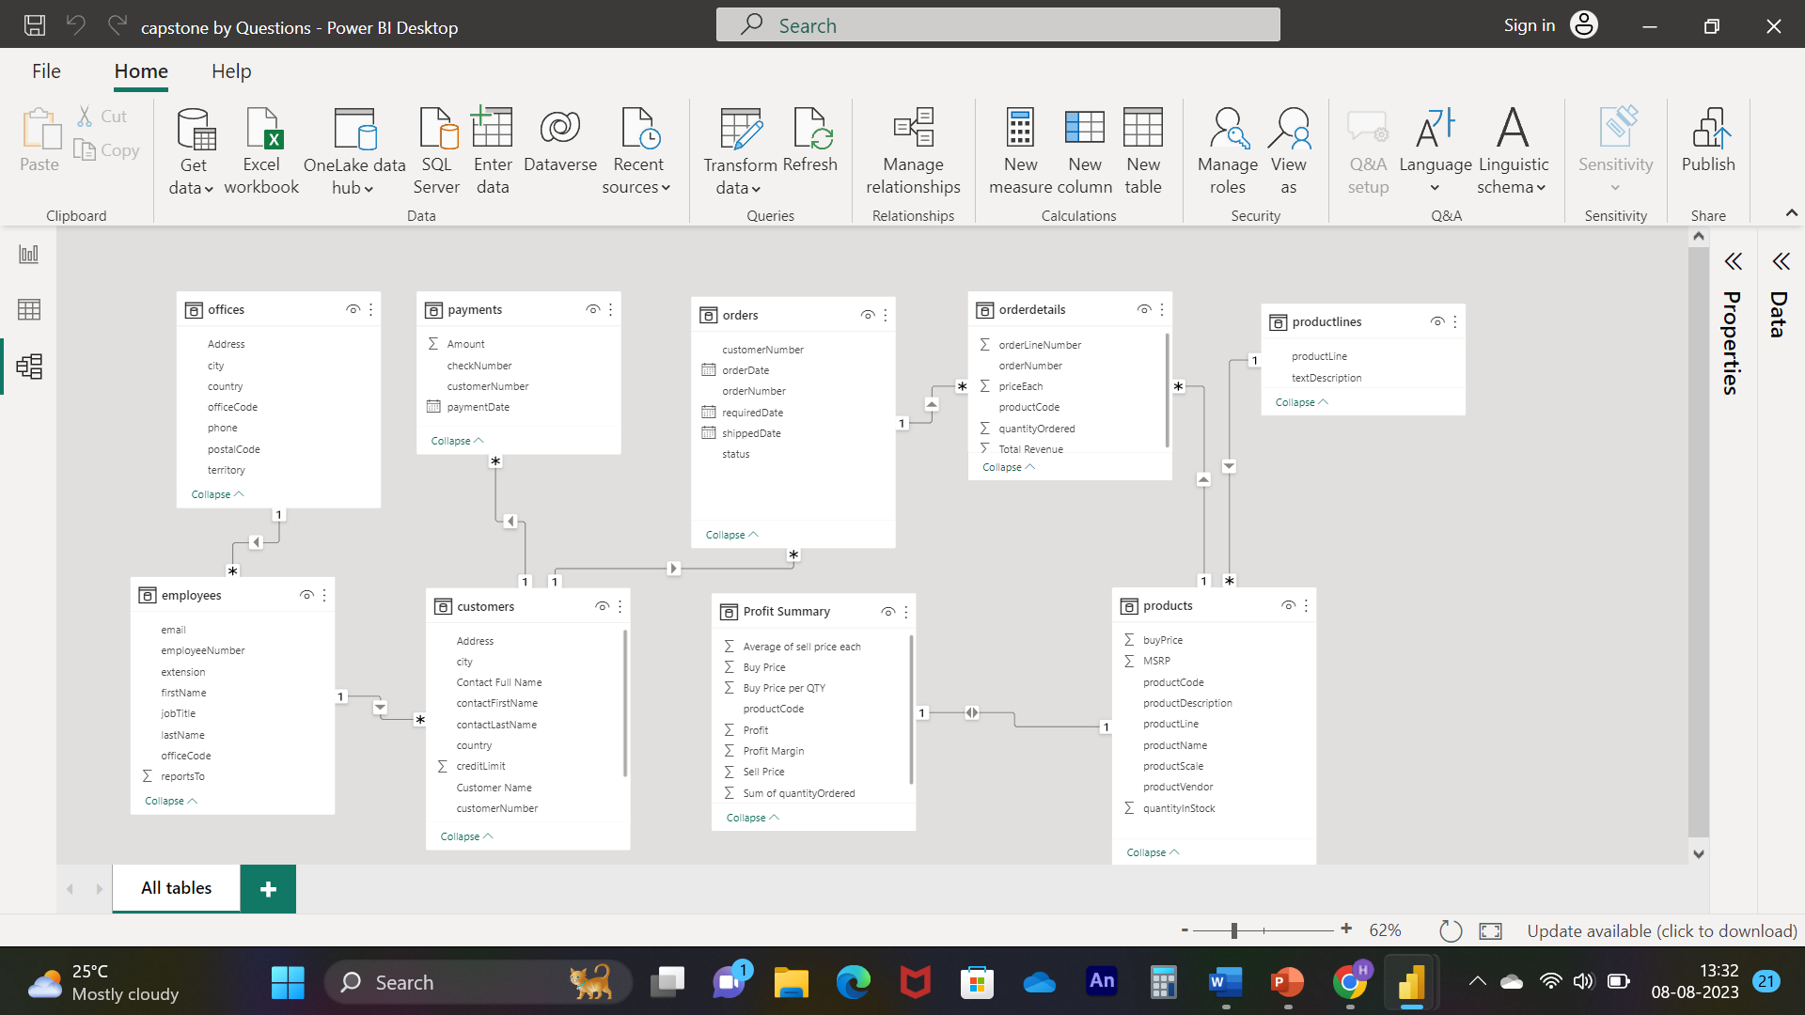

**Power BI Problem Statements**

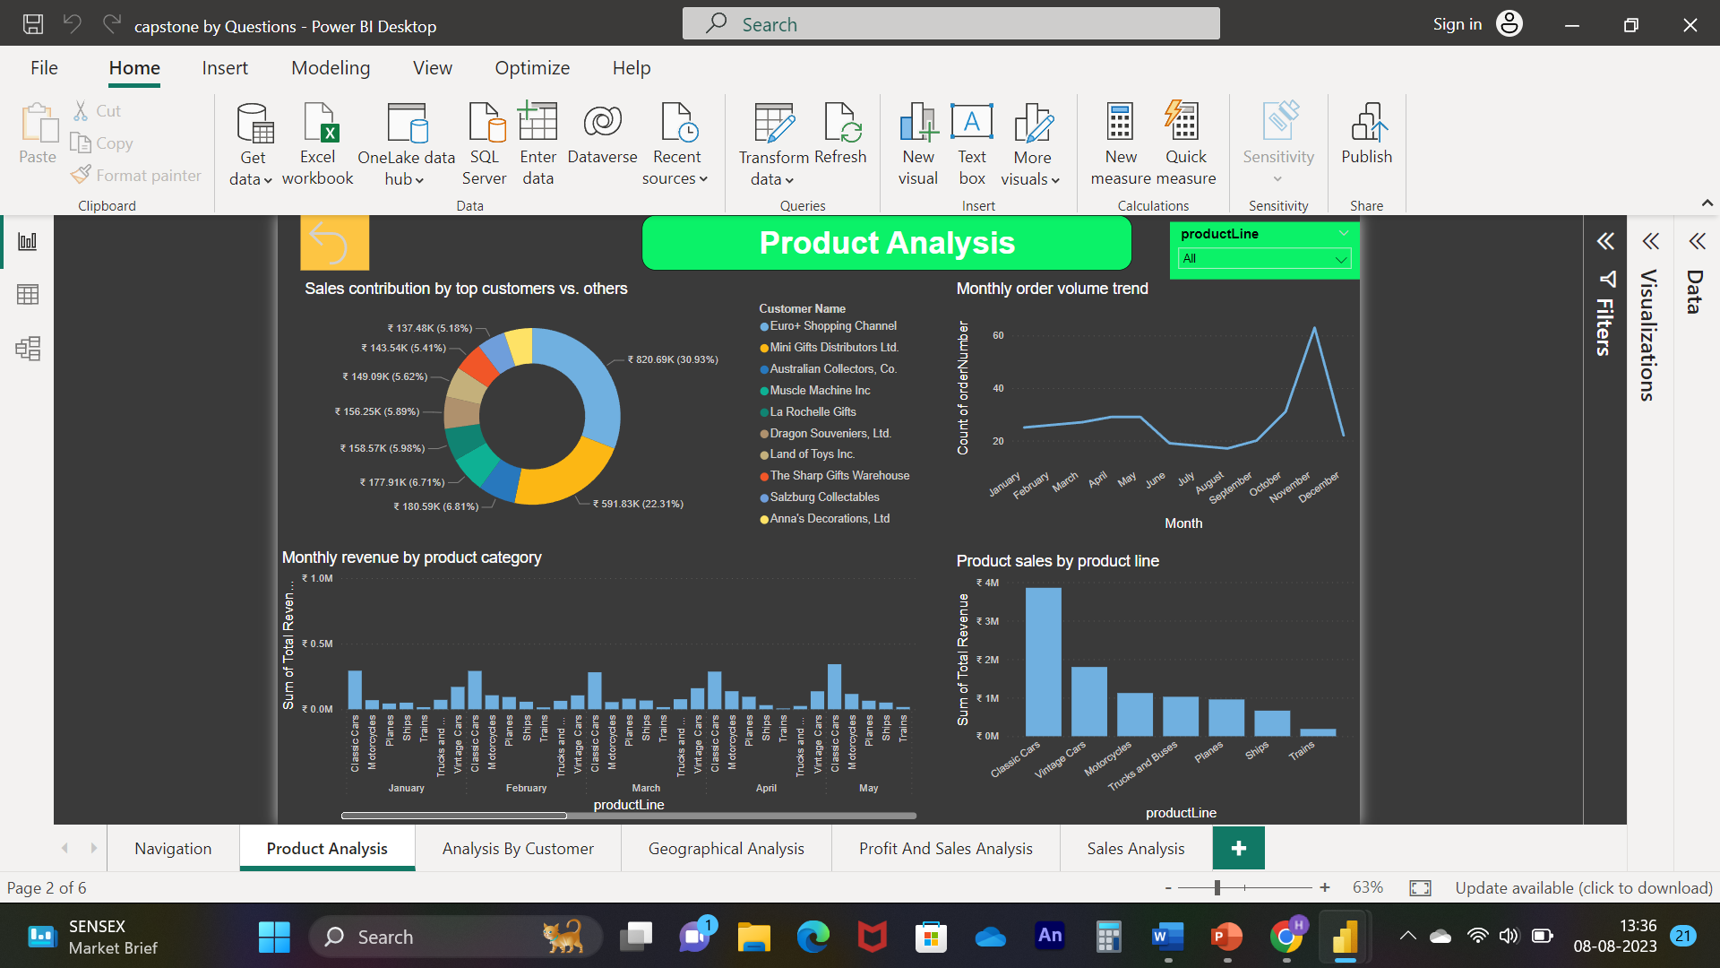

**How does monthly revenue vary across different product categories?**

As we can see in the visuals the CLASSIC CAR has more revenue in every

months as compare to other category, in fact in the MAY it was highest

revenue making category

﻿November in product Line made up 8.54% of Total Revenue.﻿

﻿

.﻿﻿ ﻿﻿ ﻿

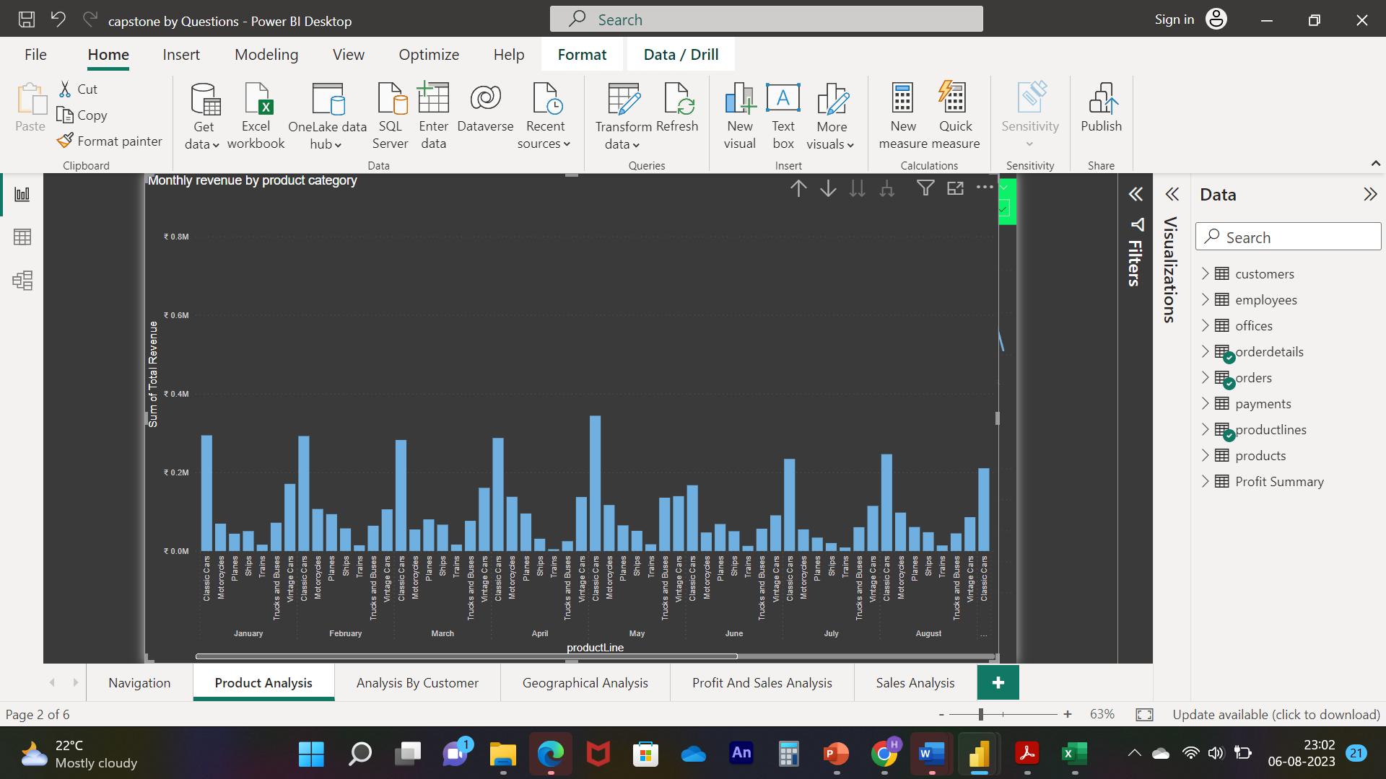

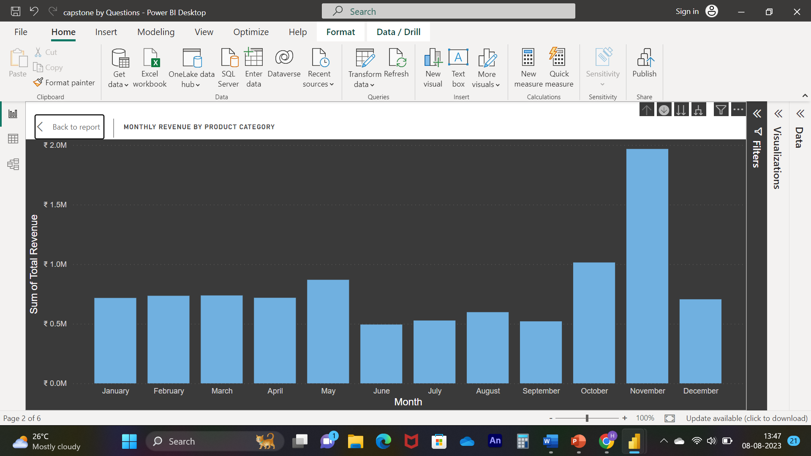

﻿ At ₹ 19,67,317.13, November had the highest Sum of Total Revenue and was

298.37% higher

than June, which had the lowest Sum of Total Revenue at

₹ 4,93,841.51.﻿﻿ ﻿﻿ November accounted for 20.48% of Sum of Total

Revenue.﻿﻿ ﻿﻿ ﻿﻿Across all 12 Month, Sum of Total Revenue ranged from ₹ 4,93,841.51 to

₹ 19,67,317.13.﻿﻿ ﻿﻿ ﻿

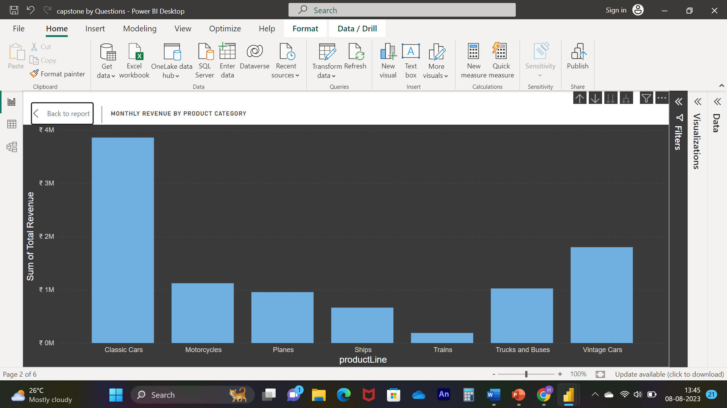

At ₹ 38,53,922.49, Classic Cars had the highest Sum of Total Revenue and was

1,944.16% higher than Trains, which had the lowest Sum of Total

Revenue at ₹ 1,88,532.92.﻿﻿ ﻿﻿ ﻿ ﻿﻿ ﻿﻿Classic Cars accounted for 40.13% of Sum of Total

Revenue.﻿﻿ ﻿﻿ ﻿﻿Across all 7 product Line, Sum of Total Revenue ranged from

₹ 1,88,532.92 to ₹ 38,53,922.49

**What is the trend in customer order volume over the past year? (Visual: Monthly order volume trend)**

As we can see in visuals in the first and second Quarter order trend was uniform in between 20 to 30 but in the 3rd quarter we can see suddenly drops of order trend which was below the 20 , and in 4th we can see suddenly spikes which was above 60 , that was highest orders in the year , so we need to analysis what kind of implementation we were made in the last quarter , and in the next coming year we need to follow the same approaches to gain more orders.

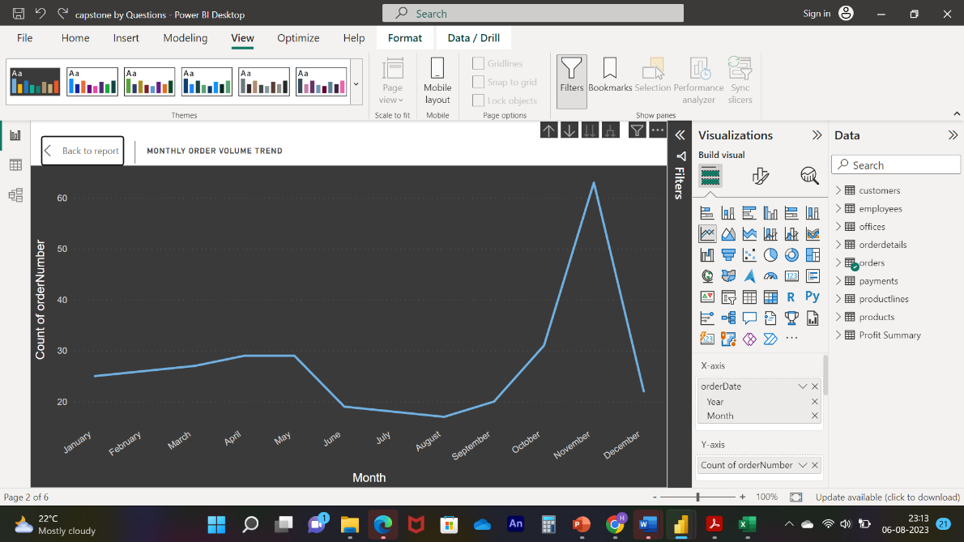

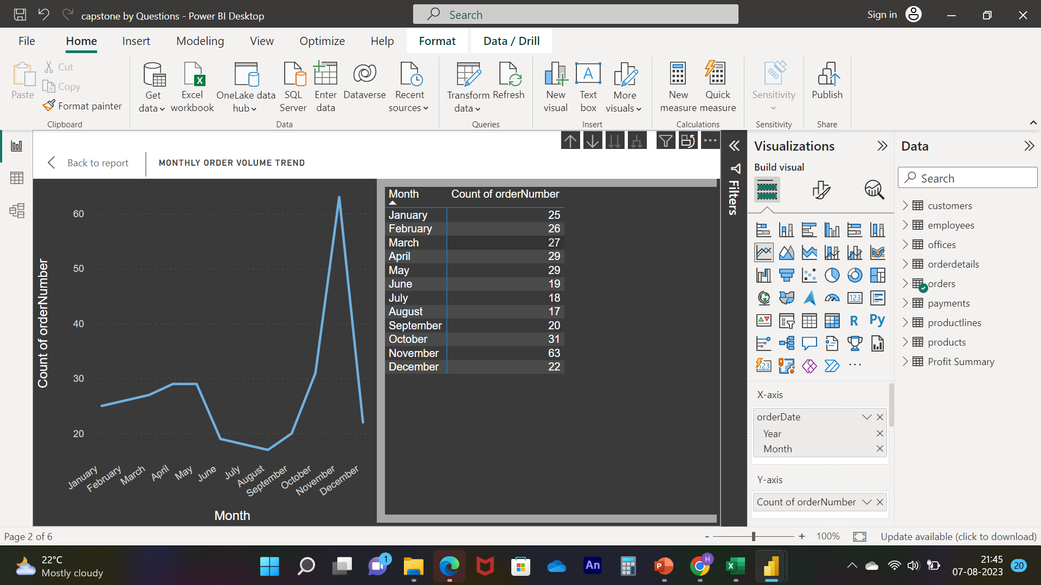

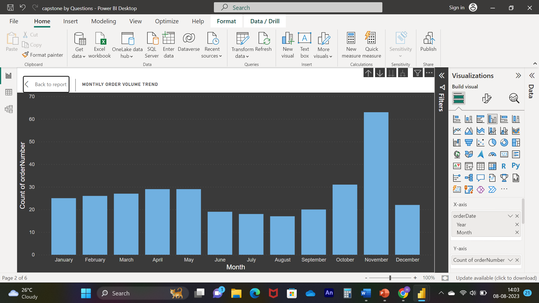

Count of orders trended down, resulting in a 12.00% decrease between January 2003 and December 2003.﻿﻿ ﻿﻿ ﻿﻿Count of orders started trending up on July 2003, rising by 22.22% (4) in 5 months.﻿﻿ ﻿﻿ ﻿﻿Count of orders jumped from 18 to 22 during its steepest incline between July 2003 and December 2003.﻿﻿ ﻿

**How does the sales performance of top customers compare to the rest? (Visual: Sales contribution by top customers vs. others)**

The visual representation of the data highlights the Top 10 Customers based on their Sales Revenue. A noticeable trend emerges wherein the leading two customers, namely "Euro Shopping Channel" and "Mini Gift Distributors Ltd," collectively contribute to over 50% of the total revenue and the number of orders.

Particularly noteworthy is the dominance of "Euro Shopping Channel," which commands a significant share of 30.93% in the Total Revenue. This underscores their substantial impact on the overall sales performance. The concentration of revenue within these top customers signifies their pivotal role in driving the business's success.

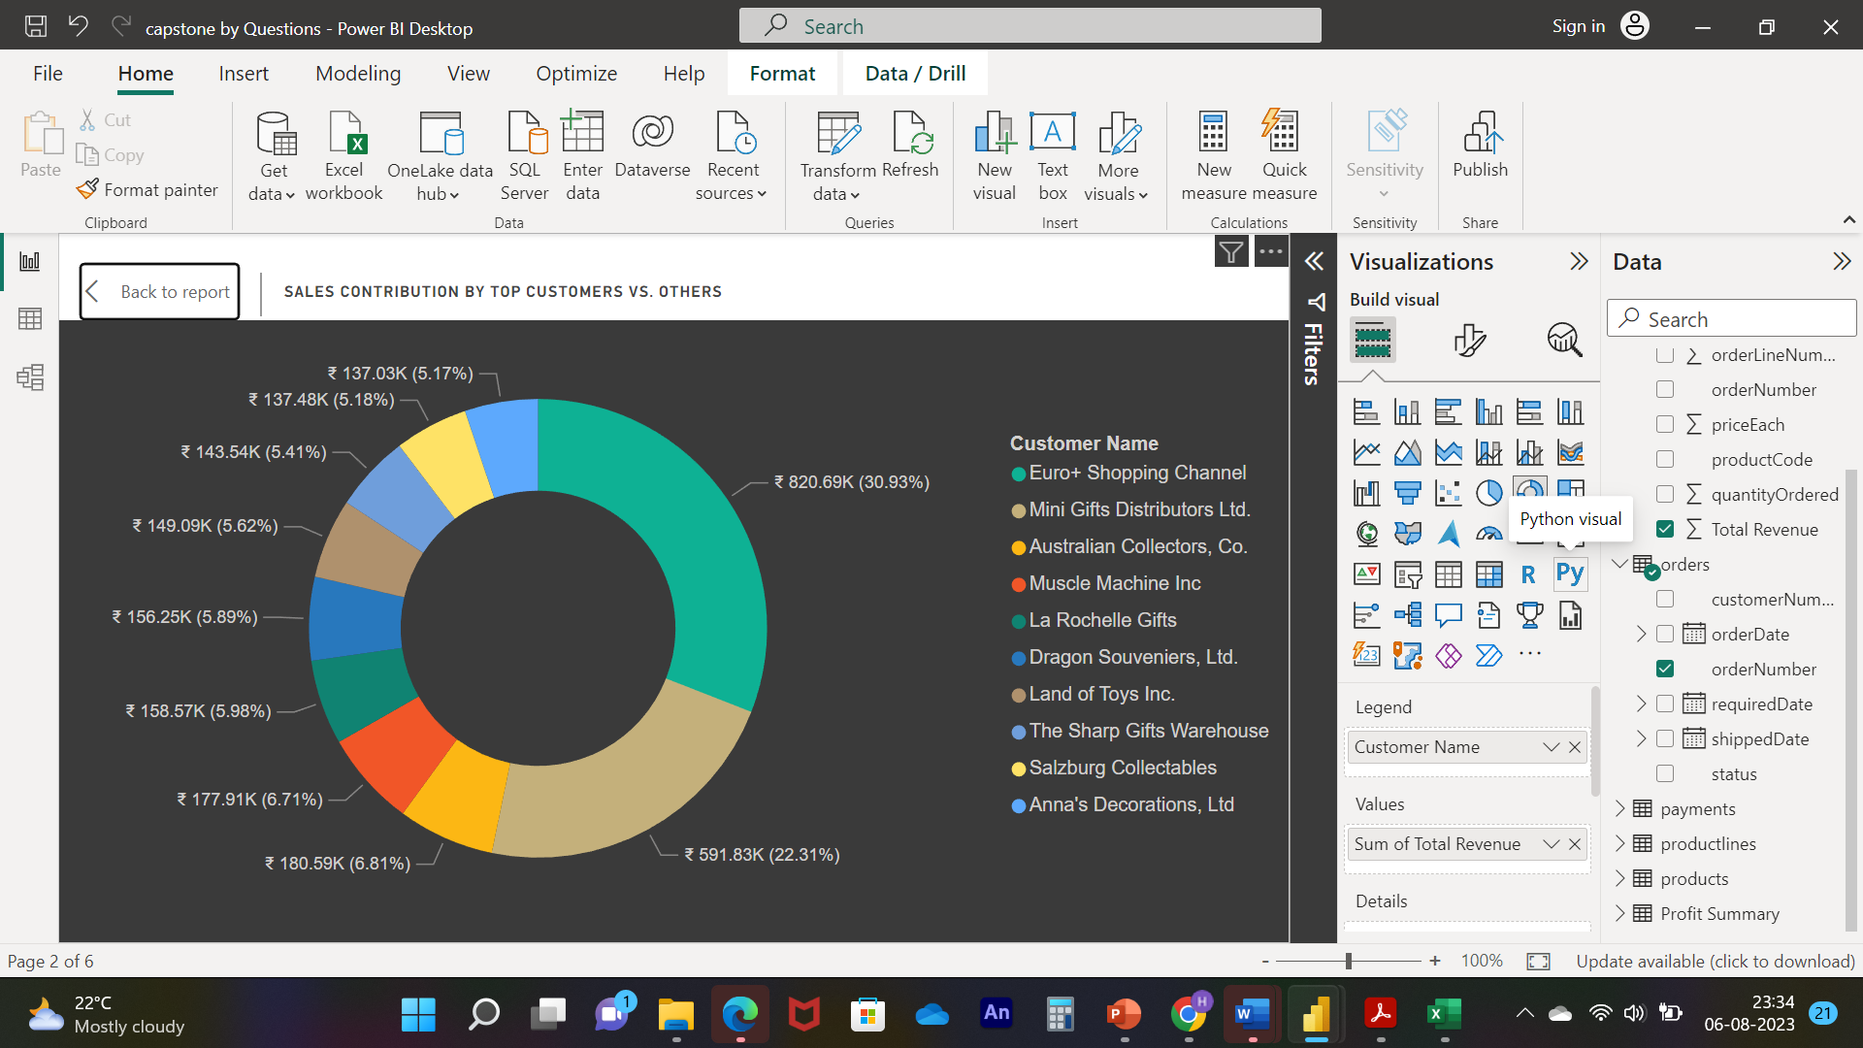

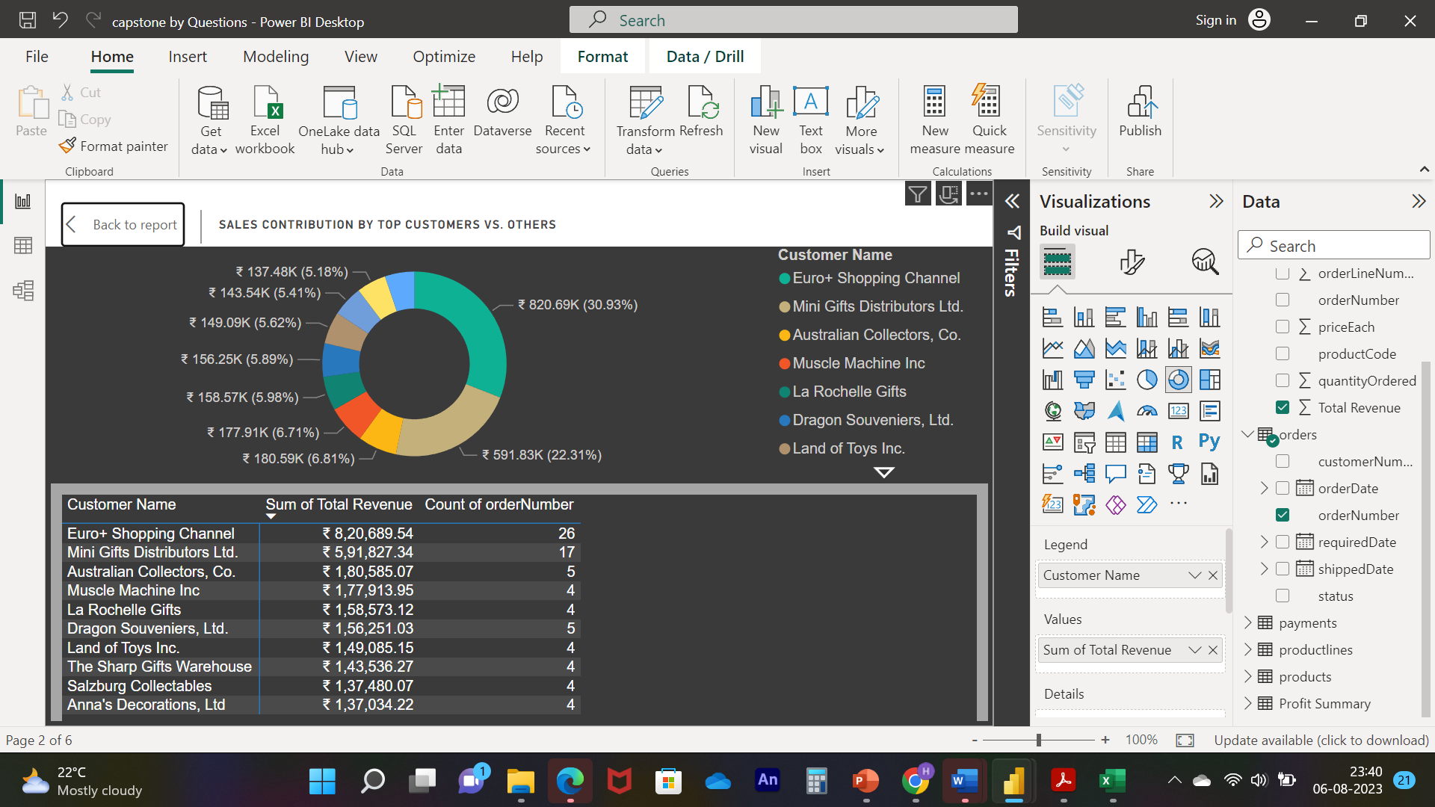

**What is the distribution of product sales across different product lines? (Visual: Product sales by product line)**

The visual analysis reveals a substantial impact from the "Classic Cars" and "Vintage Cars" categories on our sales. These categories exhibit remarkable potential to outperform other product lines. However, to ensure sustained growth, it is imperative that we direct our attention toward nurturing and expanding our other product categories. Should these categories underperform, it might necessitate considering replacements with related segments or parts to optimize results.

"Classic Cars" stands out with an impressive revenue of ₹38,53,922.49, signifying a substantial 1,944.16% higher revenue than the lowest-performing category, "Trains," with ₹1,88,532.92 in revenue. Remarkably, "Classic Cars" account for a noteworthy 40.13% of the Total Revenue, underscoring their significant contribution.

The spectrum of Total Revenue across all 7 product lines spans from ₹1,88,532.92 to ₹38,53,922.49, encapsulating the diverse revenue potential of these lines. This data underscores the need for strategic planning to harness the strengths of the high-performing categories while addressing the performance gaps in others. By taking a proactive approach to category management, we can drive sustained growth and ensure a well-rounded product portfolio.

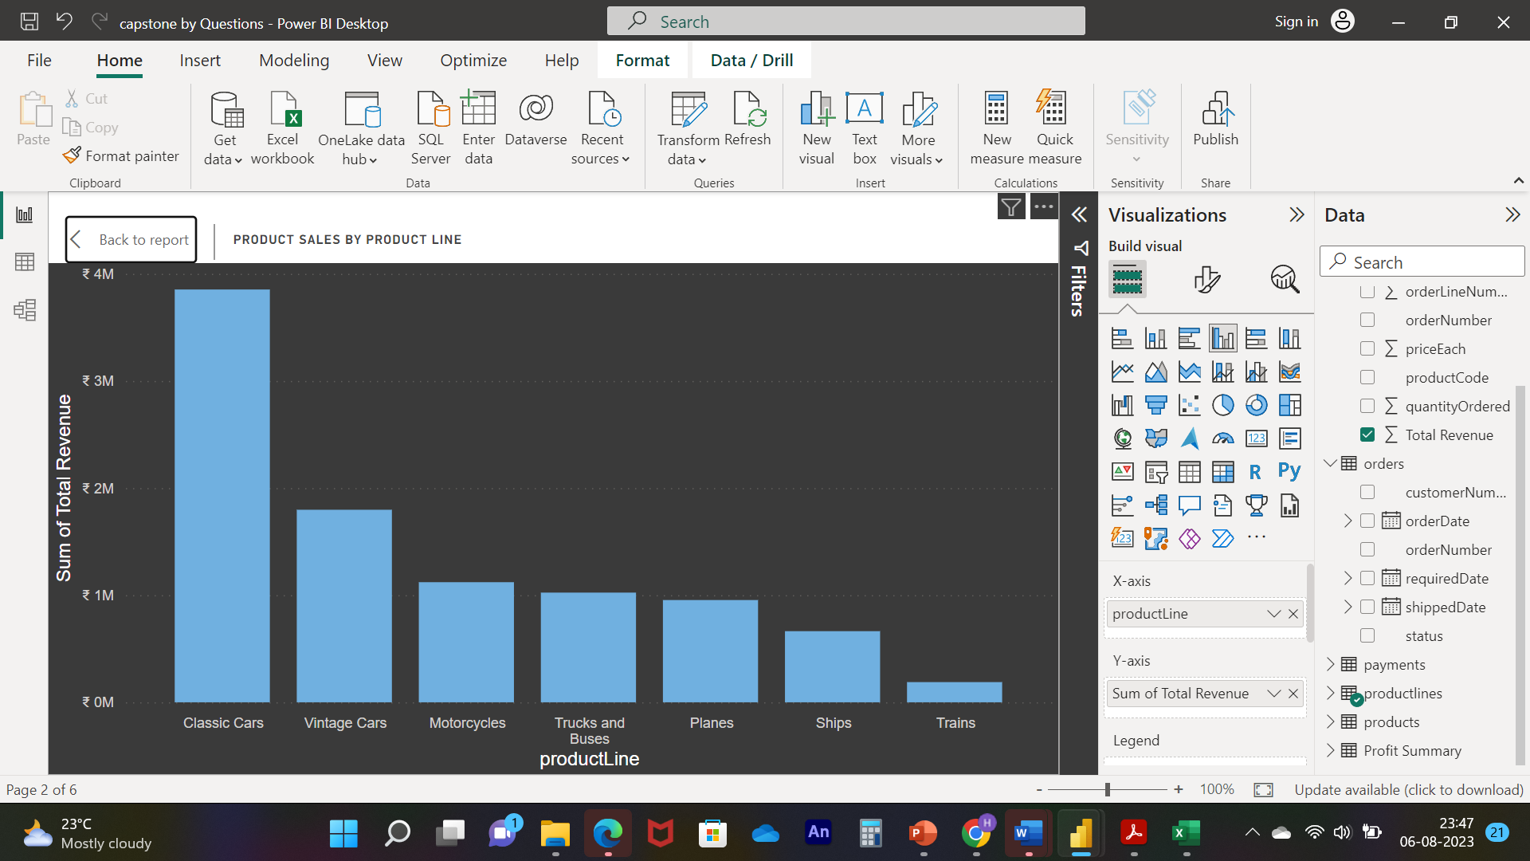

**How does product pricing impact sales volume? (Visual: Product price vs. sales volume)**

The visual analysis draws attention to the significant impact of two product pricing points in comparison to others. Among the observed data points, ₹77.9 stands out with the highest order quantity of 2780, marking a substantial increase of 262.45% over ₹34.21, which has the lowest order quantity at 767.

The order quantities are as follows:

₹77.9 had the highest order quantity of 2780, followed closely by ₹33.3 and ₹60.62.

₹34.21 had the lowest order quantity at 767.

Notably, ₹77.9 holds a considerable share of 2.63% of the total order quantity, emphasizing its influence in driving customer demand.

The order quantities across all 107 product price points range from 767 to 2780, showcasing the diverse demand landscape within this dataset. The concentration of orders around certain price points suggests the importance of strategic pricing and product positioning.

To capitalize on these insights, it's advisable to focus on understanding the factors contributing to the success of the high-performing price points and consider optimizing strategies for the lower-performing ones. This approach can enhance overall sales and customer engagement, leading to a more effective pricing and product assortment strategy.

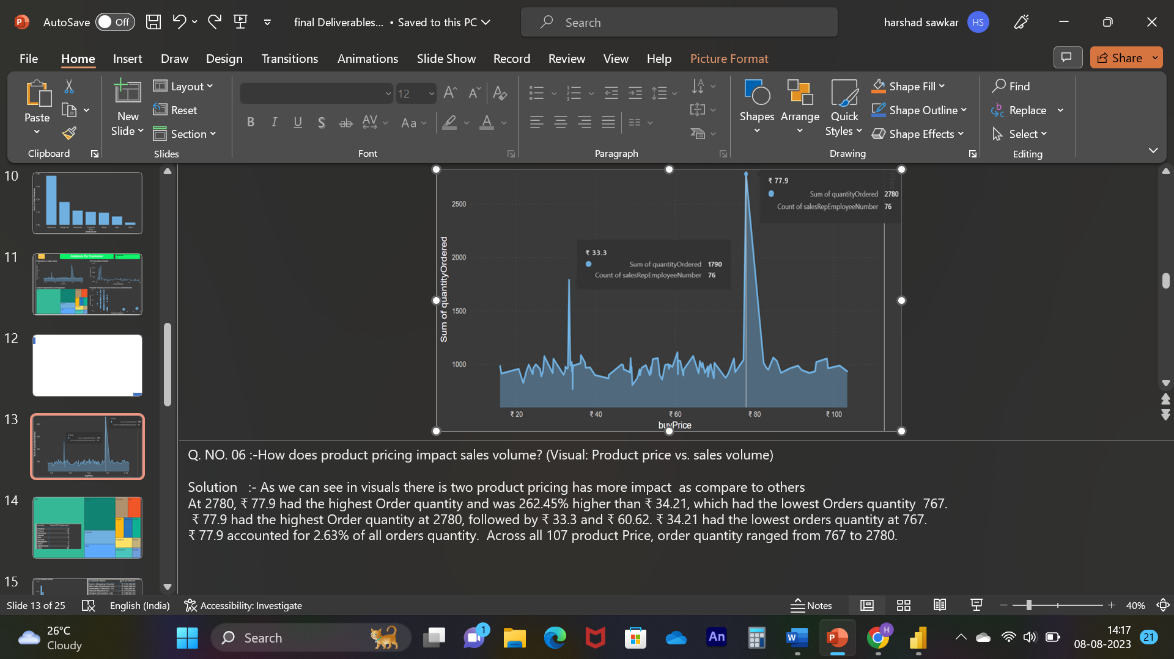

**What is the distribution of customers across different demographic segments? (Visual: Customer segmentation by demographics)**

As we can see in visual we get more number of customers from USA which is 36 and followed by France which is 12 , we also need to focus on to get more numbers of customers from other regions as well because as we can see in the market every year there is lot of competition are coming so for maintaining balance as well as smooth business

Count Of Customers was highest for USA at 36, followed by France and Australia.﻿﻿ ﻿﻿ ﻿﻿USA accounted for 47.37% of Count Of Customers.﻿﻿ ﻿﻿ ﻿﻿Across all 13 country, Count Of Customersranged from 1 to 36. 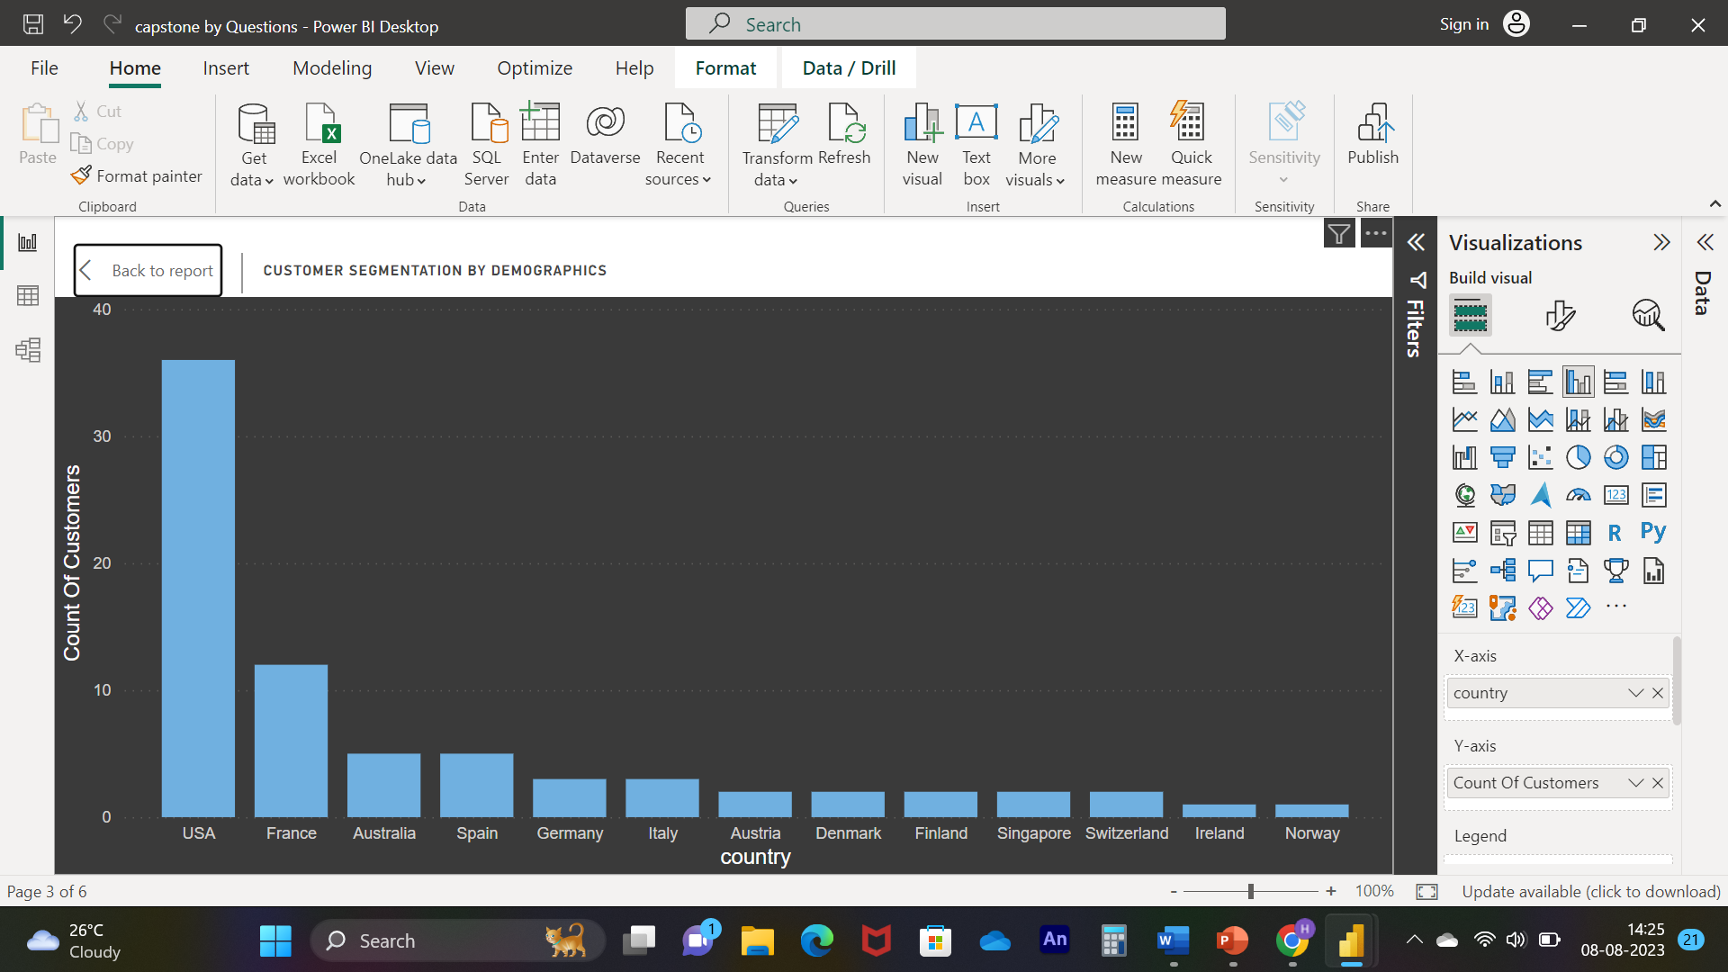

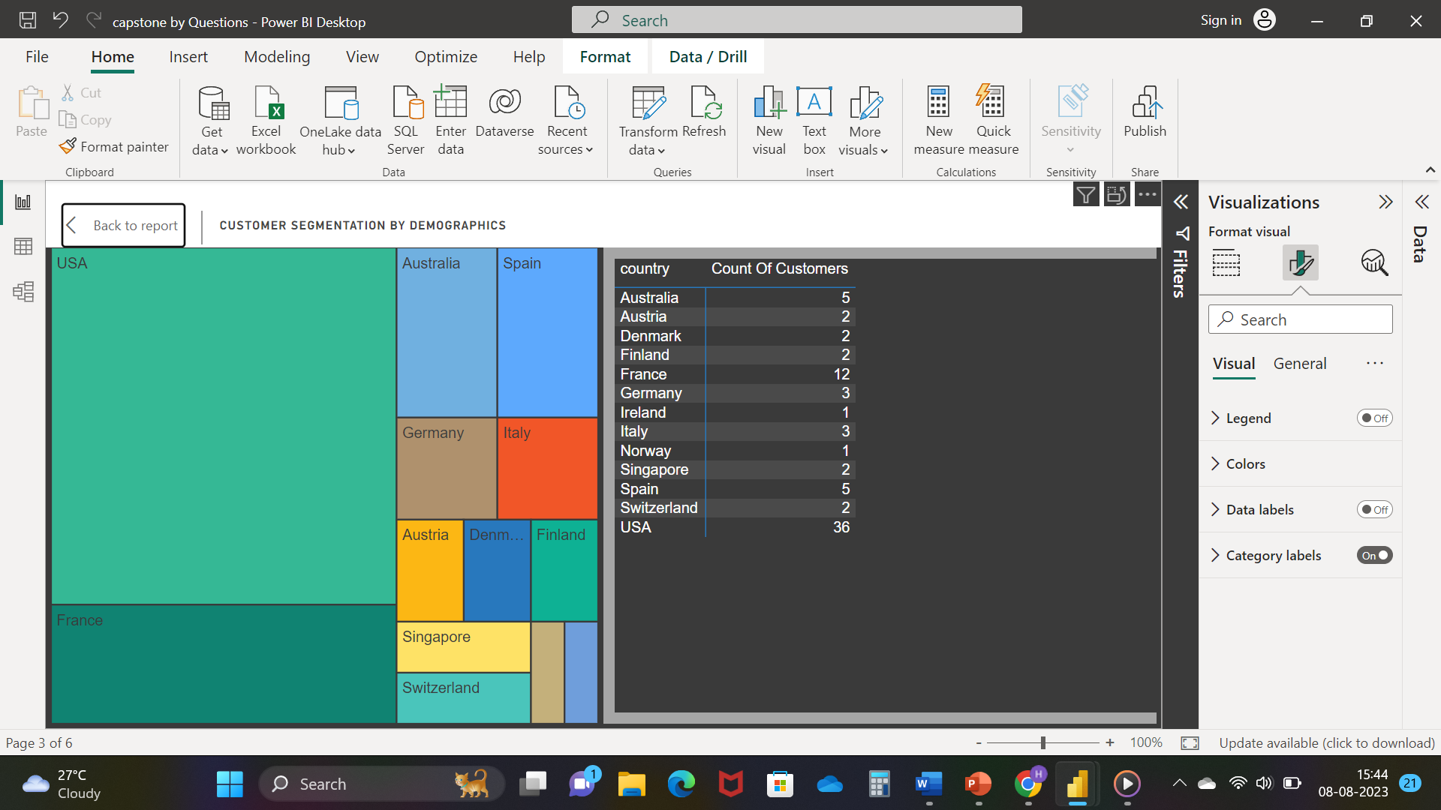

**How does customer lifetime value vary for different customer acquisition channels? (Visual: CLTV by acquisition channel)**

Notably, "Euro Shopping Channel" emerges as a standout performer with the highest Sum of Amount, amounting to ₹7,15,738.98. This value is remarkably higher by 8,938.71% compared to the lowest-performing "Boards & Toys Co.," which has a Sum of Amount at ₹7,918.6.

Key observations include:

"Euro Shopping Channel" holds a substantial share of 10.14% of the overall Sum of Amount, highlighting its significant contribution to the business's financial performance.

The spectrum of Sum of Amount across all 74 Customer Names spans from ₹7,918.6 to ₹7,15,738.98, indicating the diverse value generated by different customers.

These insights underscore the importance of understanding and optimizing customer relationships to maximize CLTV. Strategic initiatives can be directed towards strengthening relationships with high-performing customers like "Euro Shopping Channel" while exploring avenues to enhance engagement and value with lower-performing customers. This data provides valuable guidance for targeted marketing, personalized customer experiences, and improved business strategies that align with customer preferences and behaviors.

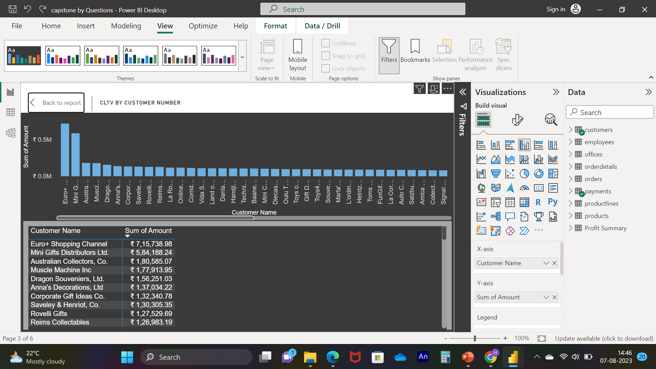

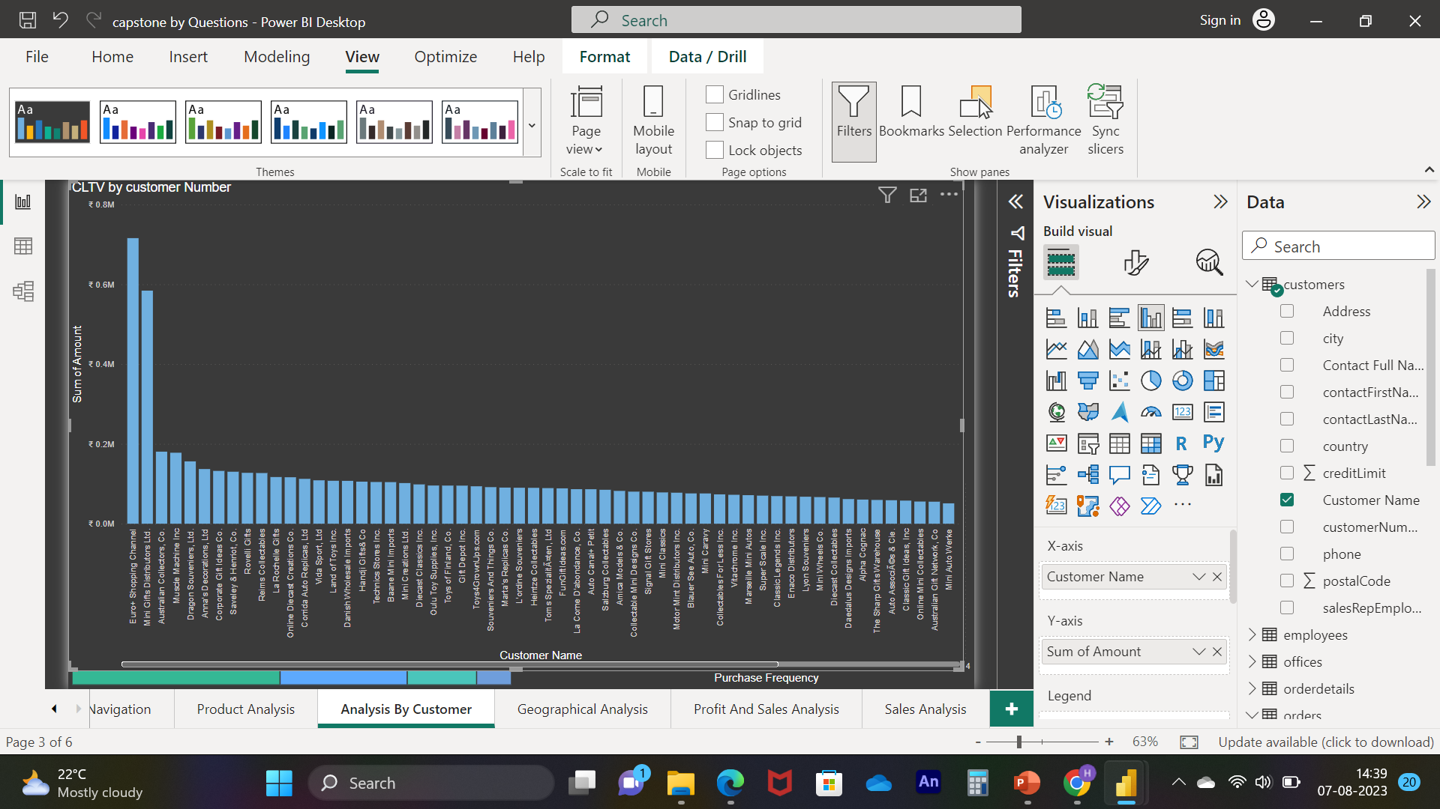

**What is the correlation between customer number and purchase frequency? (Visual: Customer Numbers vs. purchase frequency)**

The visual data representation draws attention to the performance metrics of different customers, focusing on the Euro Shopping Channel as a notable example.

Specifically, "Euro Shopping Channel" stands out with the highest Purchase Frequency of 13, which signifies the number of times purchases were made by this customer. Additionally, it also boasts the highest Sum of Amount at ₹7,15,738.98, reflecting the total monetary value of their purchases. The customer with the highest Purchase Frequency and Sum of Amount is identified as Customer Number 141.

Some key takeaways from this analysis include:

A majority of Customer Names exhibit a Purchase Frequency below 3, indicating that they make purchases relatively infrequently.

Similarly, most customers have a Sum of Amount below ₹95,341.53, suggesting that their total spending is relatively moderate.

These insights underline the distribution of customer behaviour and spending patterns, helping to identify high-value customers like "Euro Shopping Channel" and those with relatively lower engagement. By recognizing such patterns, businesses can tailor their marketing efforts and customer relationship strategies accordingly. This can include strategies to encourage higher purchase frequencies among the majority of customers and to further engage and retain those who contribute significantly to the Sum of Amount, like the prominent example of "Euro Shopping Channel."

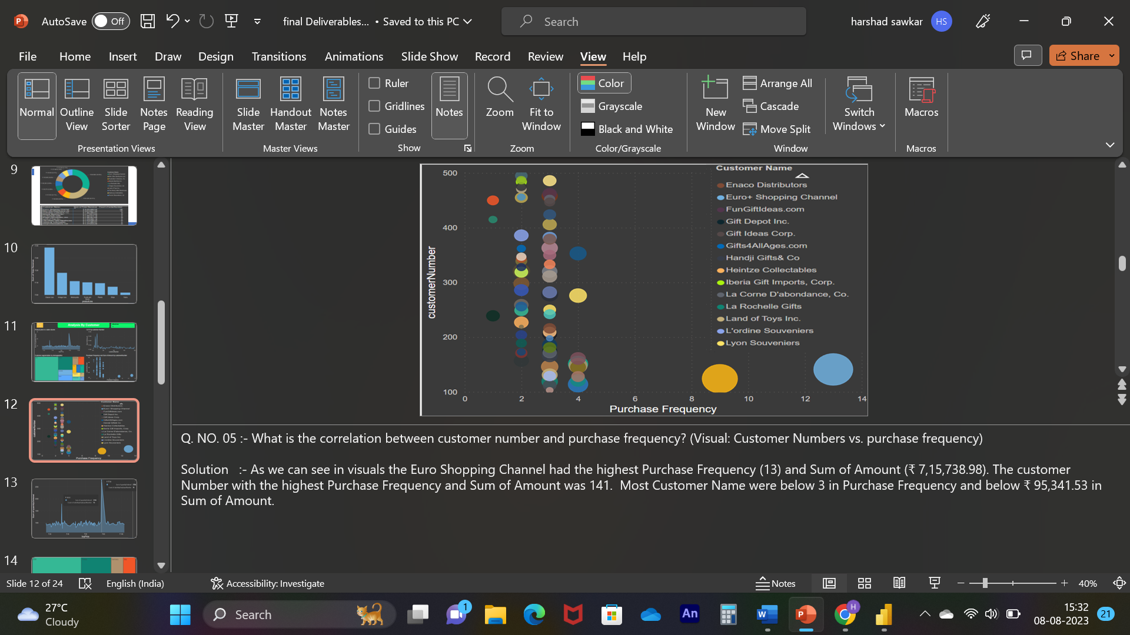

**What is the correlation between customer age and purchase frequency? (Visual: Customer age vs. purchase frequency)**

for above statement we don’t have sufficient data to know age so instead of this we

consider new problem statement

**New Q. what is the relation between Revenue and Orders, are they correlated with each other?**

Visual representations highlight that November stood out with the highest revenue at ₹19,67,317.13. This value was notably 298.37% higher than June, which had the lowest revenue at ₹4,93,841.51.

Furthermore, there seems to be a positive correlation between revenue and total orders. This suggests that when the revenue increases, there is a corresponding increase in the total number of orders.

Digging deeper into the specific months, November's revenue was particularly significant, accounting for 20.48% of the total revenue. This indicates that November was a crucial month for generating revenue.

Interestingly, the divergence between Total Revenue and Count of Orders was most pronounced in November. During this month, the Total Revenue exceeded the Count of Orders by ₹19,66,701.13. This discrepancy indicates that the average revenue per order was considerably higher in November compared to other months.

These insights underscore the importance of understanding revenue trends and their relationships with order counts. The substantial revenue generated in November suggests that there might have been higher-value transactions during that period, contributing to the increased revenue despite a relatively lower count of orders.

For the business, it's valuable to delve further into the factors that led to the significant revenue in November, as this insight can inform strategies to optimize revenue in other months as well. Additionally, exploring the correlation between revenue and order counts can help identify patterns and opportunities for maximizing overall profitability.

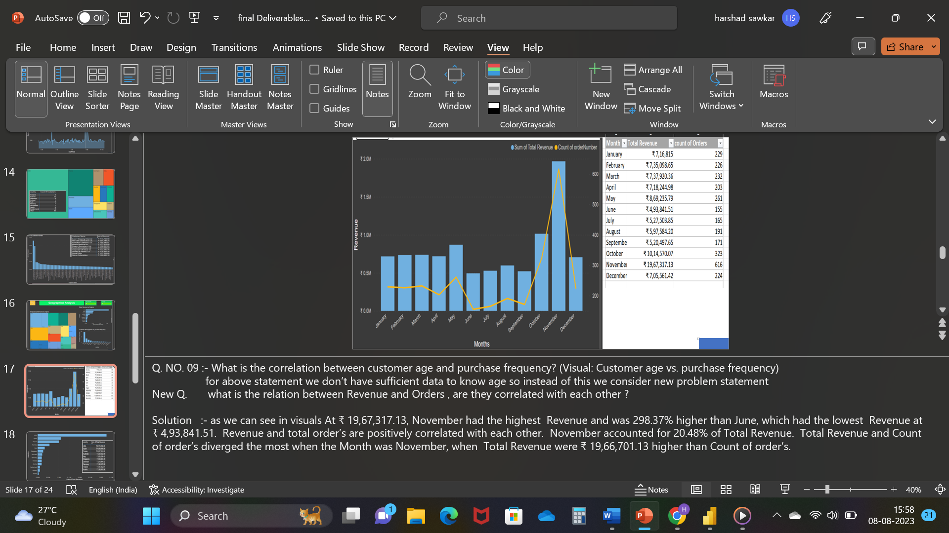

**What are the top regions in terms of sales revenue? (Visual: Sales revenue by region)**

Visual representations illustrate that the USA achieved the highest total revenue, amounting to ₹32,73,280.05. This figure stood out prominently, being 6,459.91% higher than Ireland's total revenue, which was the lowest at ₹49,898.27.

The USA accounted for a substantial portion of the total revenue, specifically 43.07%. This reinforces the fact that the USA was a major driver of revenue for the business.

Looking across all 13 countries, the total revenue varied from ₹49,898.27 to ₹32,73,280.05. This broad range underscores the diversity in revenue contributions from different regions.

Furthermore, examining the provided table, it's evident that the top contributors to the total revenue are the USA and Spain. These two countries are leading the pack in terms of revenue generation.

These insights provide valuable information for the business's international strategy. The dominance of the USA and the prominence of Spain in contributing to total revenue suggest that these markets should be a primary focus. However, it's also important to ensure a balanced approach and explore opportunities for growth in other countries. By analyzing the factors that make the USA and Spain successful revenue generators, the business can potentially replicate these strategies in other regions and optimize its overall revenue generation.

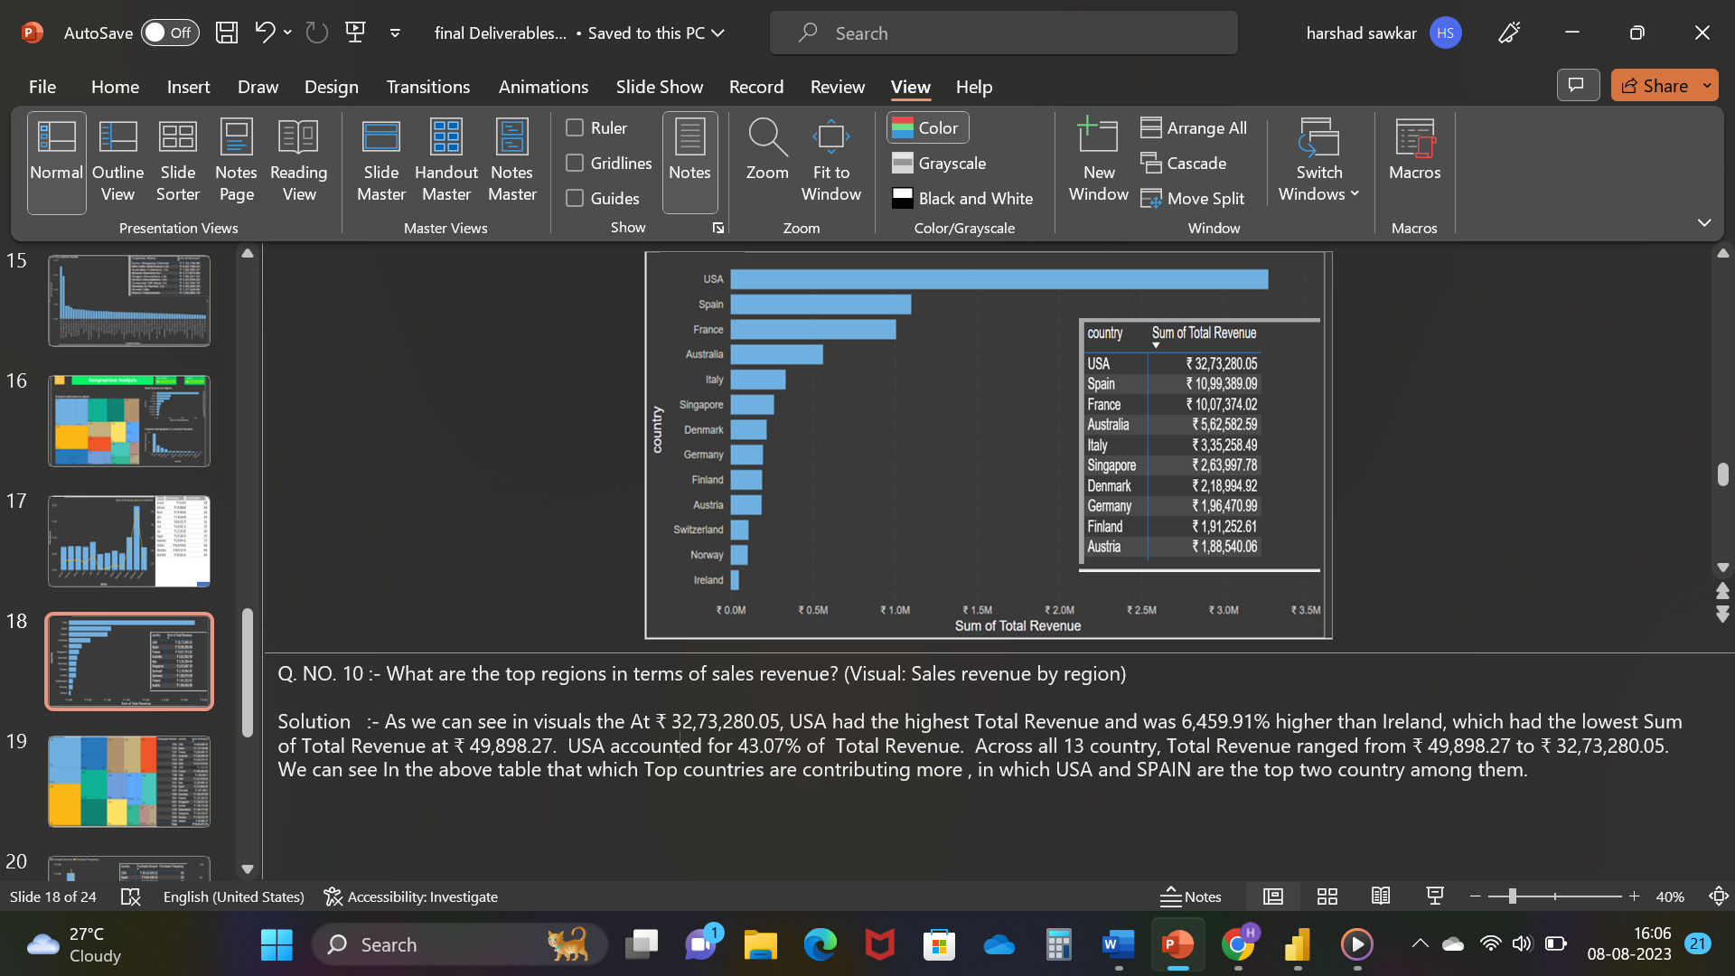

**How does the performance of sales employees vary across different regions? (Visual: Employee performance by region)**

Visual representations show that the employee numbered 1165 in the USA country accounted for 14.03% of the total sum of amounts. This suggests that this particular employee's contributions significantly influenced the overall revenue generated.

In terms of the total sum of amounts, USA took the lead with the highest total sum at ₹30,40,029.52. Spain, France, and Singapore followed closely behind, indicating their significant contributions to the overall revenue.

Furthermore, when considering the average sum of amounts, USA retained its top position with the highest average amount per employee, reaching ₹5,06,671.59. Again, Spain, France, and Singapore came next in line.

These insights highlight the remarkable contribution of the employee with the number 1165 in the USA, underscoring their role in driving a notable portion of the overall revenue. The dominance of the USA, Spain, France, and Singapore in both total and average sum of amounts points to the significance of these countries in the business's revenue generation.

To leverage these insights, the business could consider analyzing the strategies or circumstances that have led to the employee 1165's exceptional contribution. Replicating successful practices or recognizing exceptional employees could potentially benefit the business's revenue generation. Similarly, understanding the factors that have led to strong performance in the USA, Spain, France, and Singapore can guide strategies to optimize revenue in other countries as well.

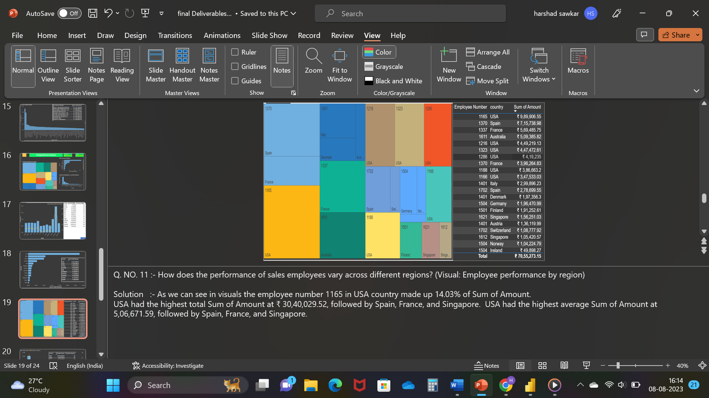

**What is the correlation between customer age and purchase frequency? (Visual: Customer age vs. purchase frequency)**

for above statement we don’t have sufficient data to know age so instead of this we consider new problem statement

New Statement: what is the repeated frequency of customers by region’s Purchase Amount

and Purchase Frequency are correlated with each other?

Visual representations show that the USA had the highest purchase amount, reaching ₹30,40,029.52. This amount was significantly higher than Ireland's purchase amount, which was the lowest at ₹49,898.27 by a factor of 5,992.45%.

Furthermore, there appears to be a positive correlation between purchase amount and total purchase frequency. This suggests that when the purchase amount increases, the overall purchase frequency also tends to increase.

Taking a closer look at specific countries, the USA accounted for a substantial portion of the total purchase amount, specifically 43.09%.

Interestingly, the largest divergence between purchase amount and purchase frequency occurred in the USA. In this case, the purchase amount exceeded the purchase frequency by ₹30,39,936.52. This suggests that, on average, individual purchases in the USA were significantly higher than the frequency at which purchases were made.

These insights underline the significance of analyzing purchase behavior in different countries. The dominance of the USA in purchase amount and the correlation between purchase amount and frequency indicate the importance of understanding the factors that contribute to higher purchase values in certain regions. By identifying the reasons behind these patterns, businesses can tailor their strategies to optimize purchase frequency and amount across different markets.

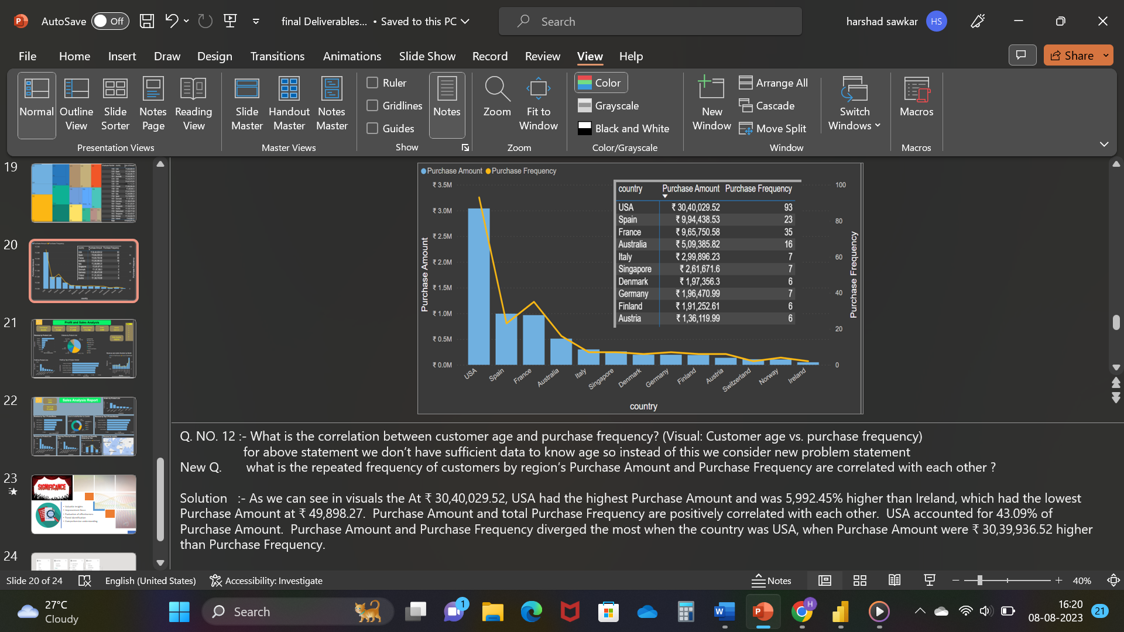

**CONCLUSION**

**Revenue Insights:**

The data reveals varying revenue patterns across different months. Notably, November stood out with the highest revenue, indicating a potential seasonality or special factors driving higher sales during that time. Further exploration into the reasons behind this spike could guide strategies for maximizing revenue during specific periods.

**Country Contributions:**

The data underscores the significance of certain countries, such as the USA and Spain, in generating a substantial portion of the total revenue. These markets appear to be crucial revenue drivers and warrant focused attention in business strategies. Diversifying revenue sources across various regions can mitigate risks associated with overreliance on a single market.

**Employee Influence:**

An individual employee, denoted as 1165, significantly impacted the overall revenue. Understanding the strategies and practices that contributed to this employee's exceptional performance could provide valuable insights for employee training and recognition programs. Recognizing high-performing individuals can motivate others and enhance overall team performance.

**Purchase Behavior Analysis:**

The relationship between purchase amounts and purchase frequency is noteworthy. Higher purchase amounts seem to be associated with increased purchase frequency, suggesting that customers who spend more also tend to make more frequent purchases. Analyzing the factors influencing these trends can inform strategies for increasing both average purchase amount and frequency.

**Market Dynamics:**

The data highlights the need to adapt to changing market dynamics. The intense competition observed annually emphasizes the importance of maintaining a balance between established markets and exploring opportunities in emerging regions. This adaptability will ensure the business remains competitive and resilient in a rapidly evolving retail landscape.

In the realm of retail analytics, these insights provide a foundation for data-driven decision-making. By leveraging the relationships between revenue, customer behavior, and market performance, the business can optimize its strategies for sustained growth, enhanced customer engagement, and improved overall profitability.

**Power BI Report Snap shots**

